(A) REQUEST DETAILS

BAX Request No: |  | Request Date: | 11 Oct, 2007
Request By: | Tay Jyh Huey | Client Name: | Apple
Priority  (E/H/M/L): | H | Application: | Omega
Expected Date of Completion:
Request Title: | Work order screen
Nature of Request (please tick):
Errors |  | New |  | Modifications |  | Others (please specify)

REQUEST DESCRIPTION
Country affected: Applecare Hub (Singapore)

Below is a screen for user to perform stock transfer or check inventory balance in Omega. Would suggest to change the qty to “available qty” and add in one column “allocated qty”, this is to allow the user to have visibility to see the status of the inventory before they perform any transfer
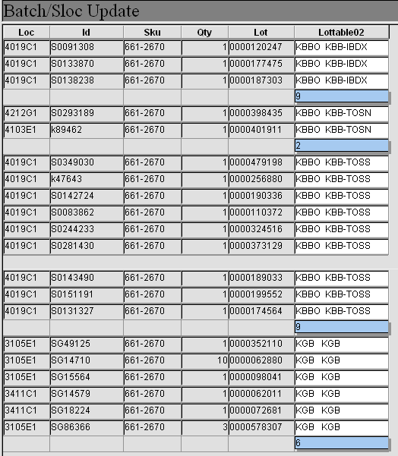

Authorized By: |  | Authorized Date:

(B) EVALUATION OF REQUEST
Comment:  (Proceed/Reject) | Proceed
Assigned To: |  | Date Assigned:
Est.Effort (man day): |  | Estimated Cost:
Est Completion date:

Timeline/ Cost Approval
Approved By: |  | Date Approved:

Acceptance of Timeline and Cost
Accepted By: |  | Date Accepted:

( C ) PROGRAMS INSTALLATION DETAILS
Update User Document (Y/N):
Scheduled installation date/time
Installation to be performed by
(D) TEST RESULT OF REQUEST
System Tested By: |  |  | Date:
User Sign-off By: |  |  | Date:
Sign-off Remarks:

Section A
Authorisation List:
BAX Program Managers
Helena Susanto (SIN), Amanda Yim (HK), Steve Hung (TW), Calvin Hong (SHA), Johnny Zhou (SYD), Lestlie Sohn (KR), ToshiakiIshii (TYO)
Apple Program Managers
Ashwani Dang
Project Managers (Project specific)
Project dependent

Section B
Evaluation of Request
Regional Business Owner
Christopher Lim, Prem Ramachandran
Regional IT Acc Mgr
Samuel Lim

Approval of Cost/Timeline
Regional IT Director
Patrick Foong

Acceptance of Cost/Timelime
Regional Business Owner, BAX Program Manager

Notes:
- Work will not start until authorized by is signed by head of dept (HOD) is completed.
- User sign-off indicates that the user has satisfied the request.

